use db;

create table Product(PID int, Pname varchar(10), cid int, price int);

insert into Product values(1,"chais",1,18);

insert into Product values(2,"chang",1,19);

insert into Product values(3,"ikura",2,6);

insert into Product values(4,"tofu",7,25);

insert into Product values(5,"pavlova",3,30);

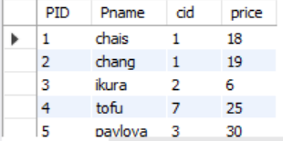

create view ProductAboveAveragePrice as

select Pname, price from Product

where price > (select AVG(price) from Product);

select \* from ProductAboveAveragePrice;

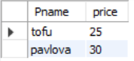

Show create view ProductAboveAveragePrice;



drop view ProductAboveAveragePrice;